**Assignment No.4**

Title:- WRITE A 64-BIT ALP TO ACCEPT 64BIT(16DIGITS)NUMBER AND DISPLAY IT ON SCREEN.

Code:-

%macro scall 4

mov rax,%1

mov rdi,%2

mov rsi,%3

mov rdx,%4

syscall

%endmacro

section .data

m1 db "Enter 64bit(16 digit) number=",10d,13d

l1 equ $-m1

m2 db "The 64bit(16 digit) number is=",10d,13d

l2 equ $-m2

m3 db " ",10

l3 equ $-m3

section .bss

num resb 20

array resb 200

char_ans resb 16

section .text

global _start

_start:

scall 1,1,m1,l1

scall 0,0,num,17

call accept_proc

mov rbp,array

mov qword[rbp],rbx

;/*************************Display 64BIT Number**************************/

scall 1,1,m2,l2

mov rbx,array

mov rax,[rbx]

call display_proc

;/**************************EXIT*******************************/

mov rax,60

mov rdi,0

syscall

;*************************ACCEPT PROCEDURE **********************

accept_proc:

mov rsi,num

mov rbx,0

mov rax,0

mov rcx,16

back:

rol rbx,04

mov al,[rsi]

cmp al,39h

jbe next

sub al,07h

next:

sub al,30h

add rbx,rax

inc rsi

dec rcx

jnz back

ret

;/********************************Display Procedure******************************/

display_proc:

mov rbp,char_ans

mov rcx,16

up3:

rol rax,04

mov dl,al

and dl,0Fh

cmp dl,09h

jbe next1

add dl,07h

next1:

add dl,30h

mov [rbp],dl

inc rbp

dec rcx

jnz up3

scall 1,1,char_ans,17

scall 1,1,m3,l3

ret

OUTPUT:-

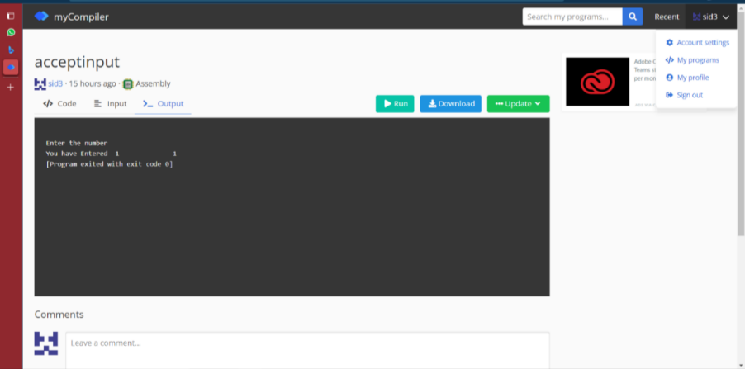

**Name**: Yashraj Vijay Aware

**Division**: D1

**Roll No**:224006

**Prn No**: 22110167